**R scripts for dose rate calculation in trapped charge dating**

Junjie Zhang1*, Sumiko Tsukamoto1,2

1Leibniz Institute for Applied Geophysics (LIAG), Hannover, Germany.

2Department of Geosciences, University of Tübingen, Tübingen, Germany.

*Email: [junjie.zhang@liag-institut.de](mailto:junjie.zhang@liag-institut.de)

# Abstract

Scripts for environmental dose rate calculation in trapped charge dating have been prepared in R language. Here, we introduce these R scripts and provide instructions for the use. Several issues in dose rate calculation are also discussed. The R scripts are freely available in GitHub at https://github.com/JunjieZhang113/R-scripts-dose-rate-calculator.

# Introduction

To date, several programs for dose rate calculation have been developed in trapped charge dating (OSL, TL and ESR). These include on-line dose rate calculators, such as DRAC (Durcan et al, 2015) and µRate (Tudyka et al., 2022), programs in exe format that can be installed in personal computers, such as AGE (Grün, 2009) and ADELE (Degering and Degering, 2020), and Excel-based programs such as LDAC (Liang and Forman, 2019).

In this short communication, we introduce an alternative way for dose rate calculation, using the code written in R language (R Core Team, 2024). These includes six R scripts for quartz and feldspar with four input CSV templates, and three R scripts for homogeneous carbonates (calcite and dolomite) with two input CSV templates. Multiple samples can be entered into each CSV template, and their dose rates will be calculated simultaneously. The calculation algorithm is the same as previous programs, such as DRAC (Durcan et al., 2015). The error of dose rate is calculated by error propagation functions. Compared to previous programs with sealed code, these R scripts are open, allowing users with basic knowledge of the R language to easily modify them to suit their preferences.

Our R scripts are capable for consideration of the Rn loss in dose rate calculation, which is not applicable in most of previous programs. We show that a 20% Rn loss will reduce the total dose rates by 3% for fine grains and 2% for coarse grains. We also discuss about the issue of alpha efficiency in alpha dose rate calculation, and demonstrate that using the *a*-value rather than the effective *k*-value will result in a total dose rate overestimation by 4.4% polymineral fine grains, and 2.3% for quartz fine grains.

# R scripts for quartz and feldspar

For quartz and feldspar, six R scripts have been prepared with different application cases: fine grains (4–11 µm), coarse grains (HF etched) and coarse grains (not etched). The coarse grains here represent any grain size between 20 and 1000 µm.

The list of the six R scripts:

***Dose rate for 4-11um Feldspar.R***

***Dose rate for 4-11um Quartz.R***

***Dose rate for coarse-grain Feldspar_etched.R***

***Dose rate for coarse-grain Feldspar_no etching.R***

***Dose rate for coarse-grain Quartz_etched.R***

***Dose rate for coarse-grain Quartz_no etching.R***

The list of the four input CSV templates:

***Template 4-11um Feldspar.csv***

***Template 4-11um Quartz.csv***

***Template coarse-grain Feldspar.csv***

***Template coarse-grain Quartz.csv***

Users can input the information of multiple samples into the corresponded template CSV file, and run the related R script. The dose rate of samples will be saved into one CSV file. The input information in the template CSV file includes: geographic information (latitude, longitude), the altitude (m), the burial depth (m), the water content (%), the gran size (µm), the concentrations of U (ppm), Th (ppm) and K (%).

Below we list the default parameters that are used in the R scripts:

Conversion factors: Liritzis et al. (2013)

Alpha attenuation factor: Brennan et al. (1991)

Beta absorption factor: Guérin et al. (2012)

Absorbed dose fraction of Rb: Readhead (2002)

Cosmic ray calculation: Prescott and Hutton (1994)

*a*-value of quartz: 0.04 ± 0.01 (e.g., Rees-Jones, 1995; Rees-Jones and Tite, 1997; Lai et al., 2008)

*a*-value of feldspar: 0.09 ± 0.02 for pIRIR signal (e.g., Kreutzer et al., 2014; Schmidt et al., 2018)

# Rn loss

As in gas phase, the 222Rn from the 238U decay chain may escape from the sediments, and cause disequilibrium in the 238U decay system (Olley et al., 1997). In this case, dose rates calculated from U concentrations will be overestimated. However, this issue has not been considered in most of previous programs. In our R scripts, the 238U decay chain is divided into two segments, pre-Rn and after-Rn, for calculating the dose rate contributed by 238U. Users can set the ‘Radon.loss’ parameter in the scripts as any value between 0 and 1. For example, a value of 0 means no Rn loss, and a value of 0.2 means 20% Rn loss. The degree of Rn loss ratio can be estimated from the 210Pb/214Pb or 210Pb/214Bi activity ratios, in case the samples have been measured by gamma spectrometry (De Corte et al., 2006).

The influence of Rn loss on the total dose rate is not significant as long as the Rn loss is less than 20%. For fine grains (4–11 µm), the dose rates with 20% Rn loss are ~3% lower compared to dose rates with no Rn loss. For coarse grains, they are ~2% lower (Fig. 1).

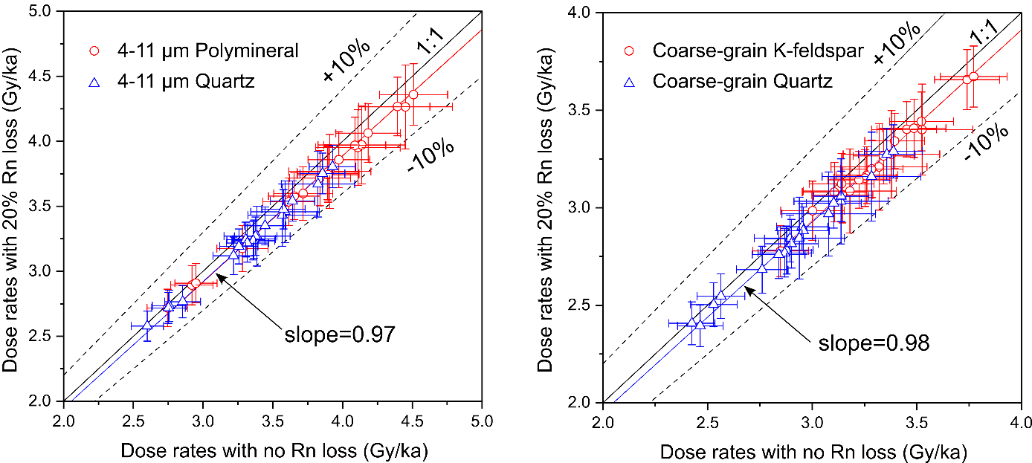

Fig. 1. Comparison between dose rates with 20% Rn loss and no Rn loss.

# Alpha efficiency

Alpha particles with higher energy is more efficient in generating luminescence signals regarding a unit loss of energy (Zimmerman, 1971). Using the *k*-value to describe the alpha efficiency, the *k*-value will increase with higher energy alpha particles. The alpha efficiency values was measured using artificial alpha sources, such as 210Po (Zimmerman, 1971), 238Pu (Tribolo et al., 2001), 244Cm (Zhang and Wang, 2020) and mostly 241Am (Biswas et al., 2013; Kreutzer et al., 2014; Lai et al., 2008; Mauz et al., 2006; Schmidt et al., 2018). In the pioneering work of Zimmerman (1971), the author assumed that all the alpha particles emitted by a 210Po source arriving at the sample aliquots had a unique energy of 3.7 MeV. The *k*-value measured by Zimmerman was called *k*3.7. Following studies also applied this assumption, and took their measured *k*-values as *k*3.7. Since the luminescence signal generated by unit length of alpha track is almost independent of the energy of alpha particles (as long as the energy is higher than 2 MeV), the *a*-value system was proposed to describe the alpha efficiency (Aitken and Bowman, 1975; Aitken, 1985). From the definition of *a*-value, the *a*-value equals to the *k*3.7.

In natural environments, the alpha particles emitted from U and Th decay chains arriving at the mineral grains has a wide energy spectrum. The overall efficiency of these alpha particles in generating luminescence is lower than a 3.7 MeV alpha particle (Zimmerman, 1971). That makes the effective *k*-value (*k*eff) in nature smaller than *k*3.7. When calculating the alpha dose rates, the *a*-value (*k*3.7) should be converted into the *k*eff value, with coefficients of 0.80 for U and 0.86 for Th, respectively (Zimmerman, 1971). Using the *a*-value directly for alpha dose rate calculation will result in ~20% overestimation for the alpha dose rate, deduced from (1-0.83)/0.83*100%. The degree of overestimation for the total dose rate depends on the relative contribution of alpha irradiation. For fine-grained feldspar (polymineral), the total dose rate will be overestimated by ~4.4%; for fine-grained quartz, the degree of overestimation reduces to ~2.3%, as the alpha efficiency of quartz is smaller (Fig. 2A-B). For coarse grains, the effect is negligible even if the grains are not etched (Fig. 2C-D).

In our R scripts, users just need to input the *a*-values. The scripts will convert the *a*-values into *k*eff values by multiplying a factor of 0.80 for U and 0.86 for Th, respectively.

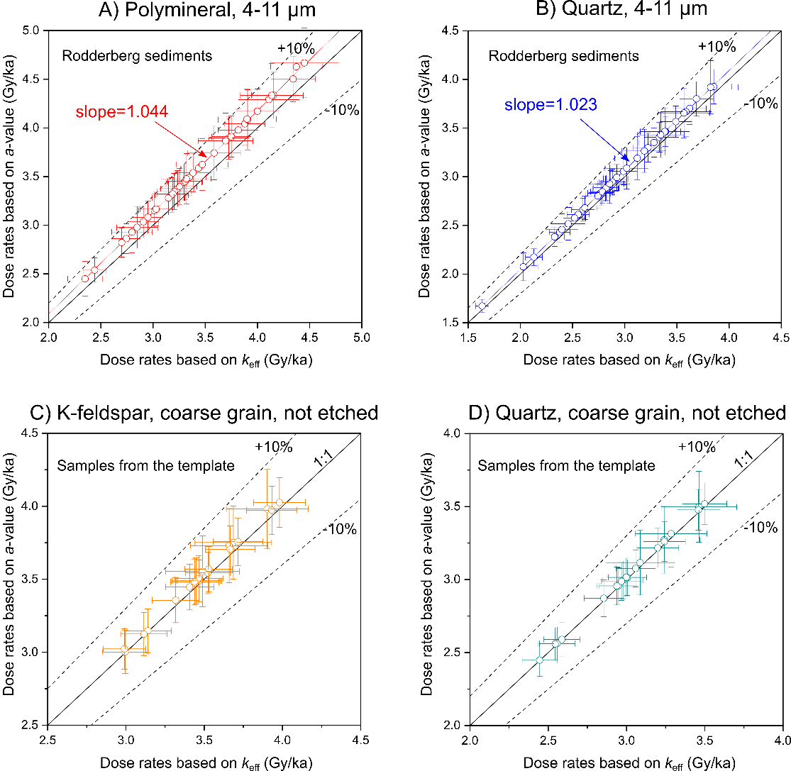

Fig. 2. Comparison between dose rates calculated with the effective *k*-value (*k*eff) and the *a*-value. A-B) Using the *a*-values, dose rates are overestimated by 4.4% for fine-grained polymineral and 2.3% for fined-grain quartz. The samples are sediments from the Rodderberg crater basin (Zhang et al., 2024b). C-D) There is negligible difference in coarse-grained samples. The coarse-grained samples are from the template CSV file, with different origins and grain sizes.

# Comparison with DRAC

The dose rates of quartz and feldspar calculated from our R scripts are compared with those calculated by the DRAC software (Durcan et al., 2015). Dose rates were calculated with no Rn loss, as DRAC cannot assume Rn loss in its calculation. In the input data of DARC, we entered the *k*eff values rather than the *a*-values. The *k*eff values were calculated by multiplying a parameter of 0.83 with the *a*-values, which are 0.033 ± 0.008 for quartz and 0.075 ± 0.017 for feldspar, respectively.

The dose rate results are identical between our R scripts and DRAC (Fig. 3).

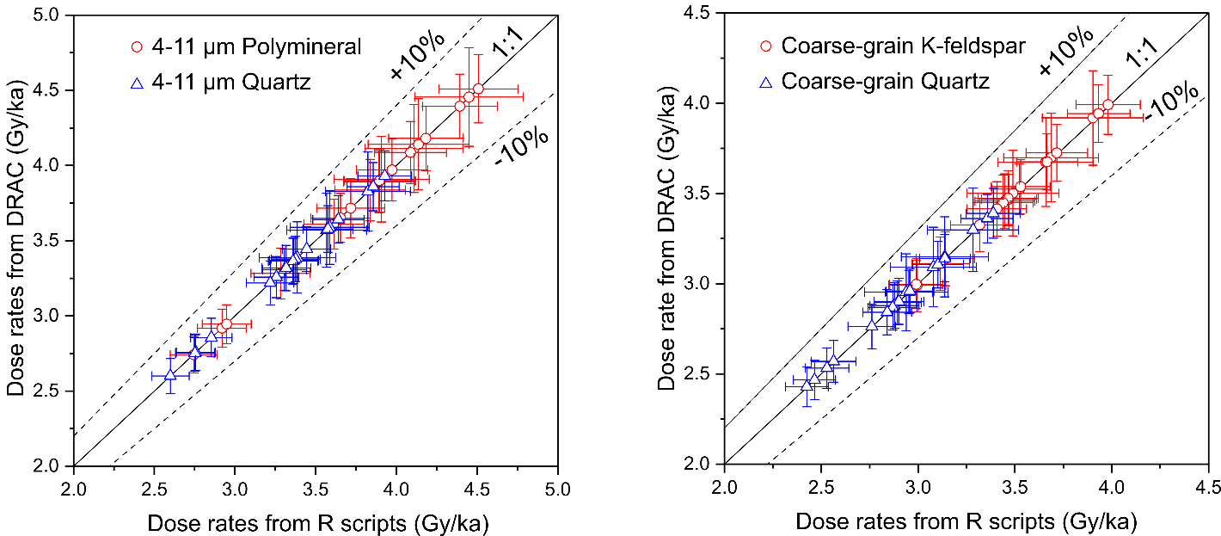

Fig. 3. Comparison between dose rates calculated from our R scripts and DRAC.

# 6. R scripts for calcite and dolomite

We have also prepared three R scripts for dose rate estimation of calcite and dolomite samples, assuming an infinite homogeneous medium.

List of the three R scripts:

***Dose rate_keff_homogeneous.R***

***Dose rate_Sa_calcite_homogeneous.R***

***Dose rate_Sa_dolomite_homogeneous.R***

List of the two input CSV templates:

***Template with keff.csv***

***Template with Sa-value.csv***

If the users apply the effective *k*-value for alpha dose rate calculation, the script of ***Dose rate_keff_homogeneous.R***should be used in combination with the ***Template with keff.csv*** file. In the template file, users should input the *k*eff value for each individual sample, because the alpha efficiency values vary significantly between different calcite or dolomite samples (e.g., Debenham and Aitken, 1984; Zhang et al., 2025). Since the alpha dose rate contributes more than 50% to the total dose rate for carbonate samples in an infinite homogeneous medium, we recommend measuring the alpha efficiency for each individual sample.

If the users apply the *S*a-value system (Guérin and Valladas, 1980) to describe the alpha efficiency, the ***Template with Sa-value.csv*** file should be used to input the *S*a-value for each sample. With the *S*a-value, the alpha flux can be converted into alpha dose rate. Since the alpha fluxes of 1 ppm U or Th in different minerals are slightly different, two R scripts were prepared for calcite and dolomite separately. Ranges of alpha particles with different energies in calcite (ρ=2.71 g cm-3) and dolomite (ρ = 2.85 g cm-3) were obtained from the software ‘The Stopping and Range of Ions in Matter’ (SRIM version 2013) (Ziegler and Biersack, 1985). With these alpha ranges, the alpha fluxes of 1 ppm U or Th in calcite and dolomite were calculated based on the energies of emitted alpha particles in their decay chains. For calcite, the alpha fluxes of 1 ppm U and 1 ppm Th are 18468 and 5166 cm-2*year-1, respectively. For dolomite, the alpha fluxes of 1 ppm U and 1 ppm Th are 18013 and 5047 cm-2*year-1, respectively. Because the ranges of alpha particles are different between different minerals, the alpha fluxes of unit ppm U and Th also change between minerals. However, the change is within 3% between quartz, K-feldspar, calcite and dolomite (e.g., Brenann and Lyons, 1989; Valladas, 1988).

Similar to the *a*-value, the *S*a-value is almost independent of the energy of alpha particles. However, when the alpha particles have energy lower than 2 MeV, the luminescence generated by unit length of alpha track decreases substantially (Aitken and Bowman, 1975; Aitken, 1985). The *S*a-values we input into the ***Template with Sa-value.csv*** file were measured with a 241Am source in the University Bordeaux Montaigne (Zhang et al., 2024a, 2025), which are slightly different from the *S*a-values in nature, as the energy spectrum of the alpha particles of the Bordeaux 241Am source arriving at the aliquots is different from that of the U and Th decay chains in nature. Correction factors of 0.92 for U and 0.96 for Th have been simulated for the measured *S*a-values, respectively (personal communication with Norbert Mercier). Thus, inside the two R scripts with the *S*a-value system, these two correction factors have been added before the *S*a-values when calculating alpha dose rates. Such correction factors should be different when different alpha sources are used for measuring the *S*a-values.

Note that these three R scripts above are only suitable for dose rates at the equilibrium state of 238U. When dating the crystallization event of carbonates (e.g., speleothem growth, shell formation), U-series disequilibrium should be considered. The variation of dose rate on time since mineral crystallization can be modelled by the R scripts in the subfolder of ‘R scripts for U disequilibrium’. For details about the modelling, please refer to Zhang et al. (2024a).

# Acknowledgements

J.Z. and S.T. thank Nobert Mercier, Chantal Tribolo, Sebastian Kreutzer, Markus Fuchs, Thomas Kolb and Mariana Sontag-González for providing the opportunities to measure *S*a-values of calcite and dolomite samples at the University Bordeaux Montaigne and the Justus Liebig University of Giessen, as well as the discussion about *S*a-value evaluation. Norbert Mercier provided the Excel template for calculating alpha fluxes of U and Th from the ranges of alpha particles. Norbert Mercier simulated the correction factors for the measured *S*a-values to account for the energy spectrum difference between the 241Am alpha source in Bordeaux and the natural environment.

# References

Aitken, M.J. *Thermoluminescence Dating*. Academic Press, London. 1985.

Aitken, M.J., Bowman, S.G.E. *Thermoluminescence dating: assessment of alpha particle contribution*. Archaeometry, 17: 132–138, 1975.

Biswas, R.H., Williams, M.A.J., Raj, R., Juyal, N., Singhvi, A.K. *Methodological studies on luminescence dating of volcanic ashes*. Quaternay Geochronology, 17: 14–25, 2013.

Brennan, B.J., Lyons, R.G. *Ranges of alpha particles in various media*. Ancient TL, 7: 32–37, 1989.

Brennan, B.J., Lyons, R.G., Phillips, S.W. *Attenuation of alpha particle track dose for spherical grains*. International Journal of Radiation Applications and Instrumentation. Part D. Tracks Radiation Measurements, 18: 249–253, 1991.

De Corte, F., Vandenberghe, D., De Wispelaere, A., Buylaert, J.-P., Van Den Haute, P. *Radon loss from encapsulated sediments in Ge gamma-ray spectrometry for the annual radiation dose determination in luminescence dating*. Czechoslovak Journal of Physics, 56: 183–194, 2006.

Debenham, N.C., Aitken, M.J. *Thermoluminescence dating of stalagmitic calcite*. Archaeometry, 26: 155–170, 1984.

Degering, D., Degering, A. *Change is the only constant - time-dependent dose rates in luminescence dating*. Quaternary Geochronology, 58: 101074, 2020.

Durcan, J.A., King, G.E., Duller, G.A.T. *DRAC: Dose Rate and Age Calculator for trapped charge dating*. Quaternary Geochronology, 28: 54–61, 2015.

Grün, R. *“AGE” program for the calculation of luminescence age estimates*. Ancient TL, 27: 45–46, 2009.

Guérin, G., Mercier, N., Nathan, R., Adamiec, G., Lefrais, Y. *On the use of the infinite matrix assumption and associated concepts: A critical review*. Radiation Measurements, 47: 778–785, 2012.

Guérin, G., Valladas, G. *Thermoluminescence dating of volcanic plagioclases*. Nature, 286: 697–699, 1980.

Kreutzer, S., Schmidt, C., DeWitt, R., Fuchs, M. *The a-value of polymineral fine grain samples measured with the post-IR IRSL protocol*. Radiation Measurements, 69: 18–29, 2014.

Lai, Z.P., Zöller, L., Fuchs, M., Brückner, H. *Alpha efficiency determination for OSL of quartz extracted from Chinese loess*. Radiation Measurements, 43: 767–770, 2008.

Liang, P., Forman, S.L. *LDAC: An Excel-based program for luminescence equivalent dose and burial age calculations*. Ancient TL, 37: 21–40, 2019.

Liritzis, I., Stamoulis, K., Papachristodoulou, C., Ioannides, K. *A re-evaluation of radiation dose-rate conversion factors*. Mediterranean Archaeology and Archaeometry, 13: 1–15, 2013.

Mauz, B., Packman, S.C., Lang, A. *The alpha effectiveness in silt-sized quartz: new data obtained by single and multiple aliquot protocols*. Ancient TL, 24: 47–52, 2006.

Olley, J.M., Roberts, R.G., Murray, A.S. *Disequilibria in the uranium decay series in sedimentary deposits at Allen’s cave, nullarbor plain, Australia: Implications for dose rate determinations*. Radiation Measurements, 27: 433–443, 1997.

Prescott, J.R., Hutton, J.T. *Cosmic ray contributions to dose rates for luminescence and ESR dating: Large depths and long-term time variations*. Radiation Measurements, 23: 497–500, 1994.

R Core Team. *R: A Language and Environment for Statistical Computing. R Foundation for Statistical Computing*, Vienna, Austria. <https://www.R-project.org/>. 2024

Readhead, M. *Absorbed dose fraction for 87Rb β particles*. Ancient TL, 20: 25–28, 2002.

Rees-Jones, J. *Optical dating of young sediments using fine-grain quartz*. Ancient TL, 13: 9–14, 1995.

Rees-Jones, J., Tite, M.S. *Optical dating results for British archaeological sediments*. Archaeometry, 39: 177–187, 1997.

Schmidt, C., Bösken, J., Kolb, T. *Is there a common alpha-efficiency in polymineral samples measured by various infrared stimulated luminescence protocols?* Geochronometria, 45: 160–172, 2018.

Tudyka, K., Koruszowic, M., Osadnik, R., Adamiec, G., Moska, P., Szymak, A., Bluszcz, A., Zhang, J., Kolb, T., Poręba, G. *μRate: An online dose rate calculator for trapped charge dating*. Archaeometry, 65: 423–443, 2023.

Tribolo, C., Mercier, N., Valladas, H. *Alpha sensitivity determination in quartzite using an OSL single aliquot procedure*. Ancient TL, 19: 47–50, 2001.

Valladas, G. *Stopping power and range for alpha particles in SiO2*. Ancient TL, 6: 7–8, 1988.

Zhang, J., Arriga, G., Rossetti, F., Argante, V., Kraemer, D., Sontag-González, M., Cosentino, D., Cipollari, P., Tsukamoto, S. *Dolomite luminescence thermochronometry reconstructs the low-temperature exhumation history of carbonate rocks in the central Apennines, Italy*. Communications Earth & Environment, 6: 252, 2025.

Zhang, J., Klose, J., Scholz, D., Marwan, N., Breitenbach, S.F.M., Katzschmann, L., Kraemer, D., Tsukamoto, S. *Isothermal thermoluminescence dating of speleothem growth – A case study from Bleßberg cave 2, Germany*. Quaternary Geochronology, 85: 101628, 2024a.

Zhang, J., Wang, L., 2020. *Thermoluminescence dating of calcite – Alpha effectiveness and measurement protocols*. Journal of Luminesence, 223: 117205, 2020.

Zhang, J., Zolitschka, B., Hogrefe, I., Tsukamoto, S., Binot, F., Frechen, M. *High-resolution luminescence-dated sediment record for the last two glacial-interglacial cycles from Rodderberg, Germany*. Quaternary Geochronology, 82: 101535, 2024b.

Ziegler, J.F., Biersack, J.P. *The Stopping and Range of Ions in Matter*, in: Bromley, D.A. (Ed.), *Treatise on Heavy-Ion Science: Volume 6: Astrophysics, Chemistry, and Condensed Matter*. Springer US, Boston, MA, pp. 93–129, 1985

Zimmerman, D.W. *Thermoluminescent Dating Using Fine Grains from Pottery*. Archaeometry, 13: 29–52, 1971.